
Business Question and Visualization Report

Date | 28 October 2026
Team ID | en25cs3010357
Project Name | Electric Vehicle (EV) Market Analysis & Performance Insights
Maximum Marks | 5 Marks

Visualization development refers to the process of creating graphical representations of data to facilitate understanding, analysis, and decision-making. The goal is to transform complex datasets into visual formats that are easy to interpret, enabling users to gain insights and make informed decisions. Visualization development involves selecting appropriate visual elements, designing layouts, and using interactive features to enhance the user experience. This process is commonly associated with data visualization tools and platforms, and it plays a crucial role in business intelligence, analytics, and reporting
Business Questions and Visualisation
The process involves defining specific business questions to guide the creation of meaningful and actionable visualizations in Tableau. Well-framed questions help in identifying key metrics, selecting relevant data, and building visualisation that provide insights.
Sample
1. What are the monthly sales trends?
  - Visualization: Line chart showing monthly sales trends.
  - Screenshot of visualisation
- Which products have the highest revenue?
  - Visualization: Bar chart comparing revenue by product
  - Screenshot of visualisation
- How is customer satisfaction varying across regions?
  - Visualization: Map visualization showing customer satisfaction by region.
  - Screenshot of visualisation

Note: Min 8 business question and visualisations Required inform of above

Business Question 1: Which EV categories lead annual sales?
Sales by Category — horizontal bar chart; two-wheeler scooters lead, with hatchbacks, compact SUVs and sedans also contributing strongly.
Tableau worksheet screenshot:
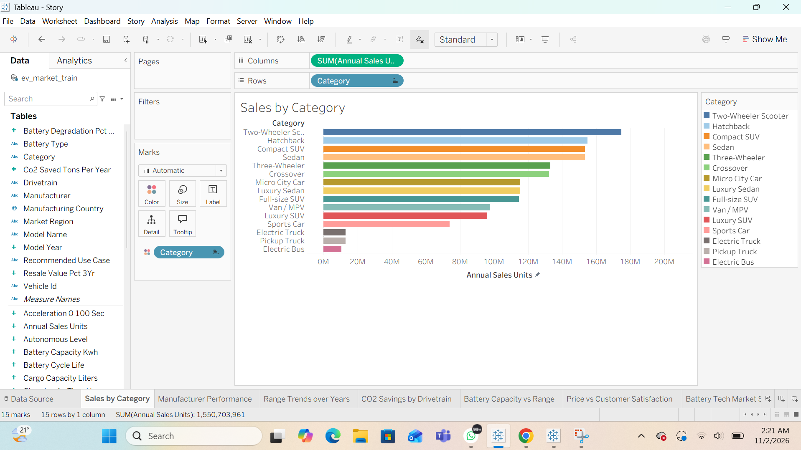

Business Question 2: How do manufacturers compare in sales?
Manufacturer Performance — ranked vertical bars for 200 manufacturers; results support competitive benchmarking.
Tableau worksheet screenshot:
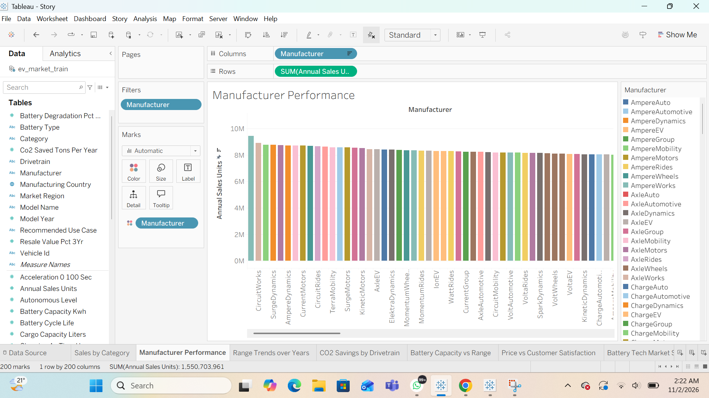

Business Question 3: How has average driving range changed by model year?
Range Trends over Years — line chart for 2018–2026; average range remains near 320–325 km in this dataset.
Tableau worksheet screenshot:
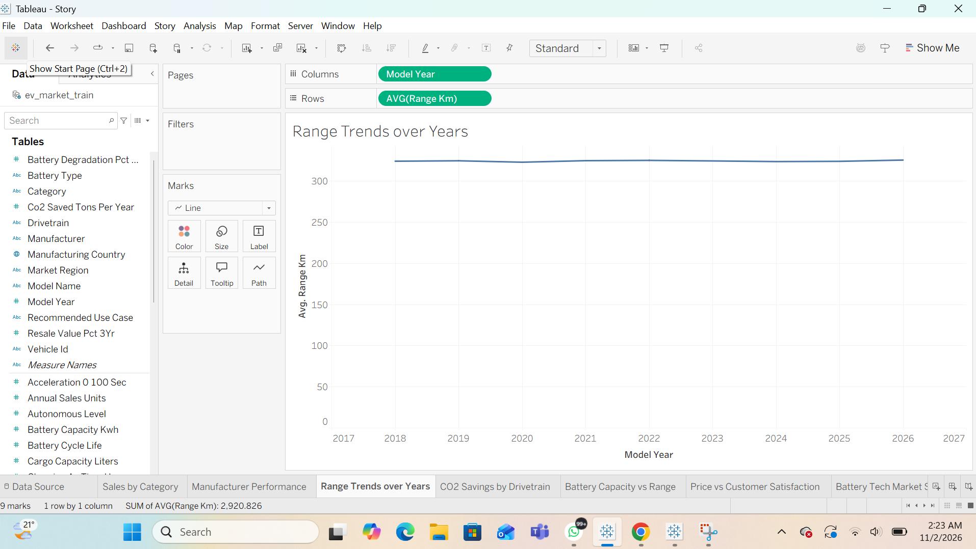

Business Question 4: How do CO2 savings differ by drivetrain?
CO2 Savings by Drivetrain — AWD averages about 3.9 tons/year, compared with about 3.5–3.7 for FWD and RWD.
Tableau worksheet screenshot:
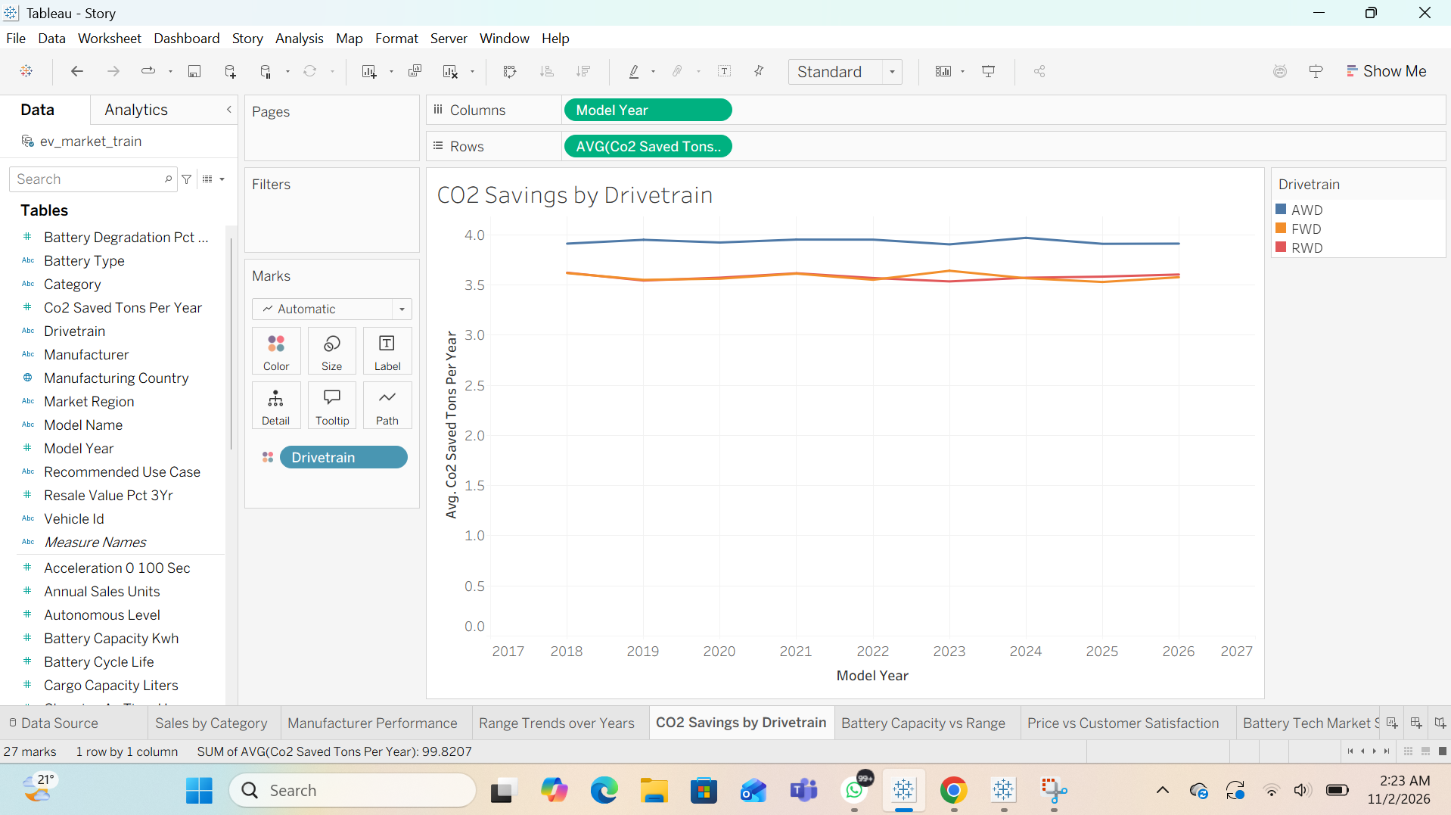

Business Question 5: How does battery capacity relate to range?
Battery Capacity vs Range — scatter plot comparing battery capacity (kWh), range (km), and five battery chemistries.
Tableau worksheet screenshot:
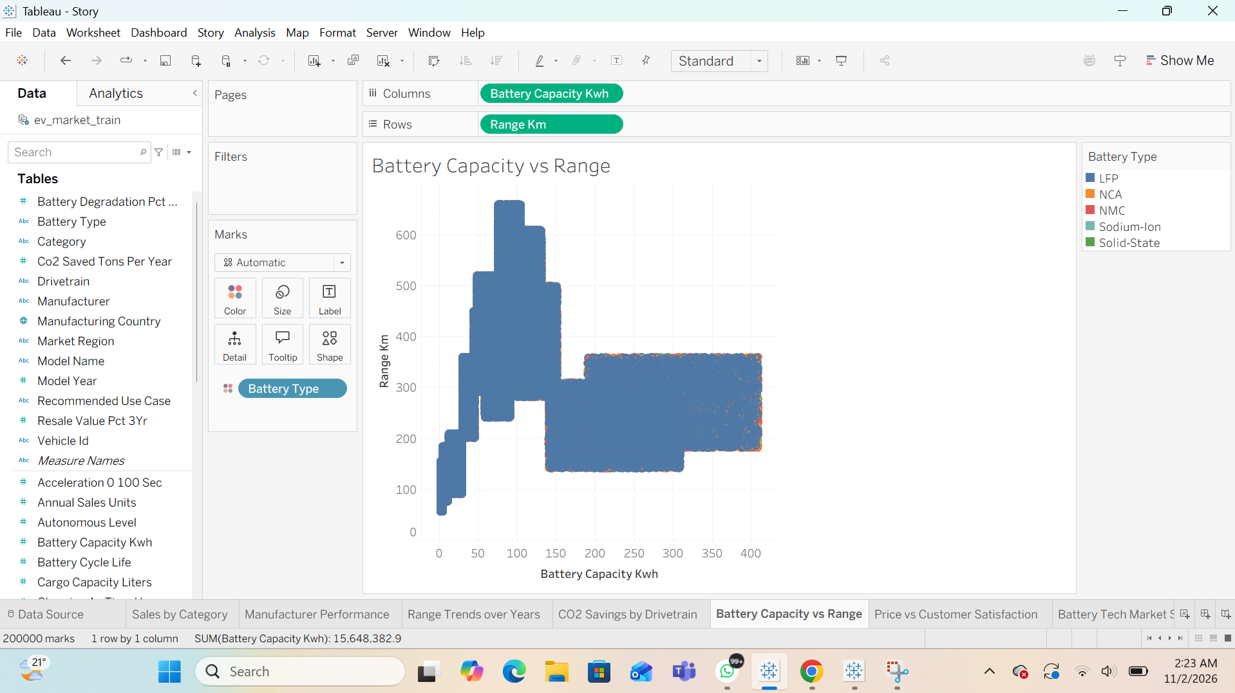

Business Question 6: Does higher price correspond to customer satisfaction?
Price vs Customer Satisfaction — scatter plot by recommended use case; ratings vary at different prices, with >4,000 nulls shown.
Tableau worksheet screenshot:
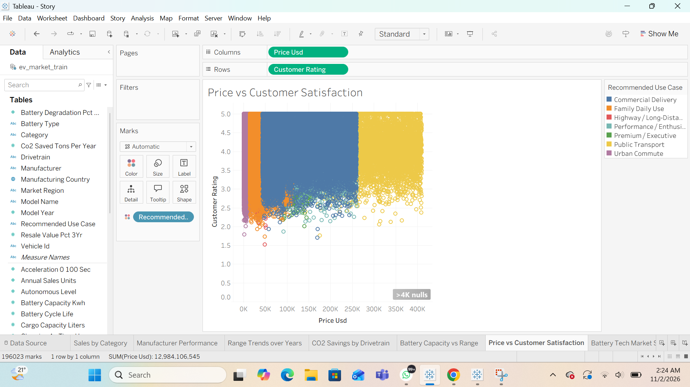

Business Question 7: Which battery technologies dominate the dataset?
Battery Tech Market Share — horizontal percent-of-total bars; NMC about 34%, LFP 32%, NCA 17%, Sodium-Ion 10%, Solid-State 7%.
Tableau worksheet screenshot:
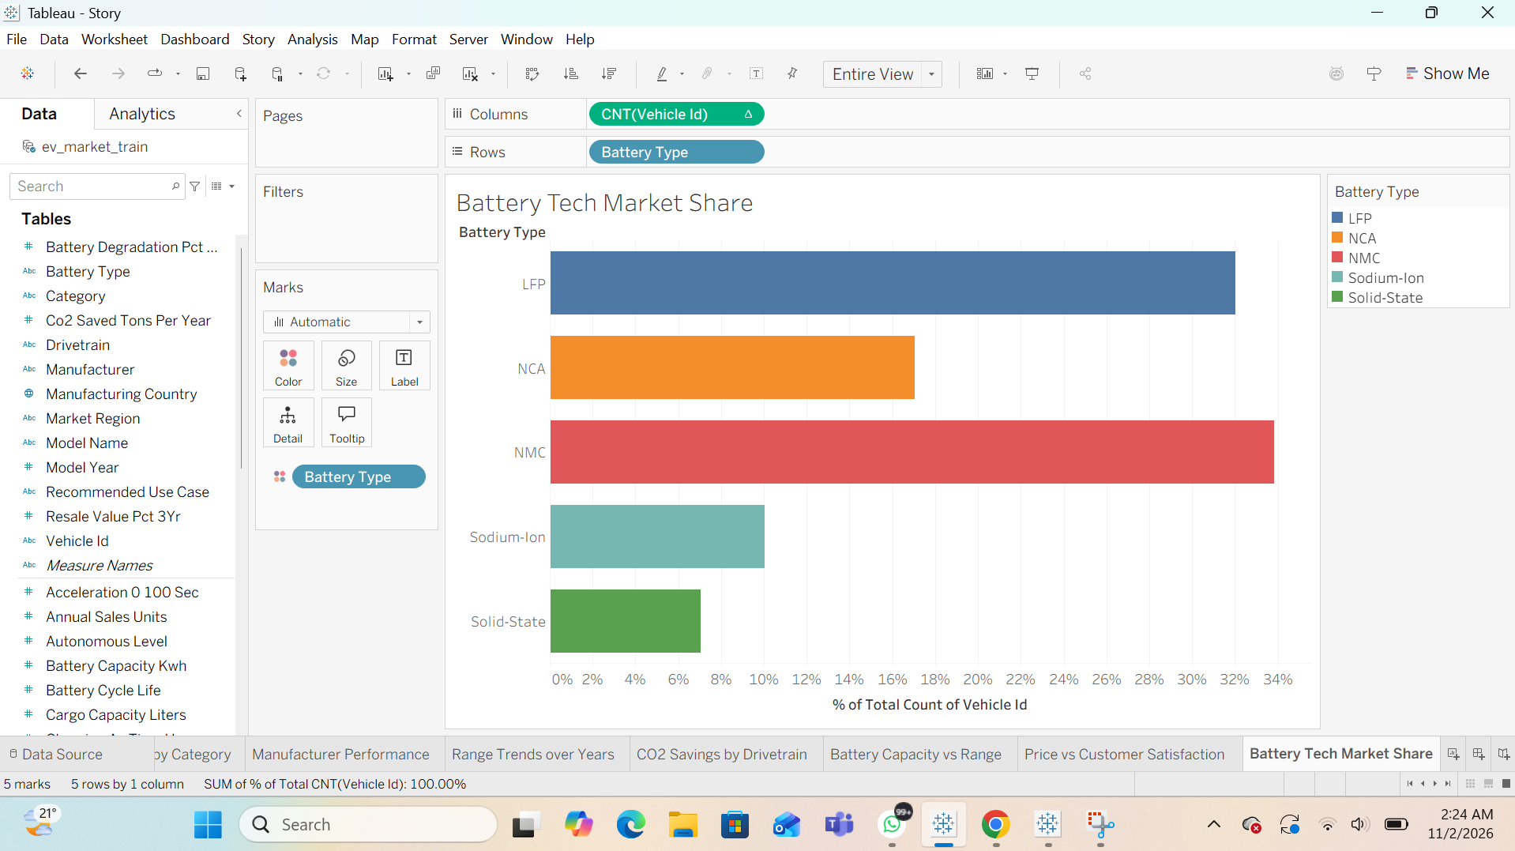

Business Question 8: How does satisfaction vary across regions?
Regional Customer Satisfaction — category-by-region heatmap; displayed mean ratings range approximately 4.06–4.12.
Tableau worksheet screenshot:
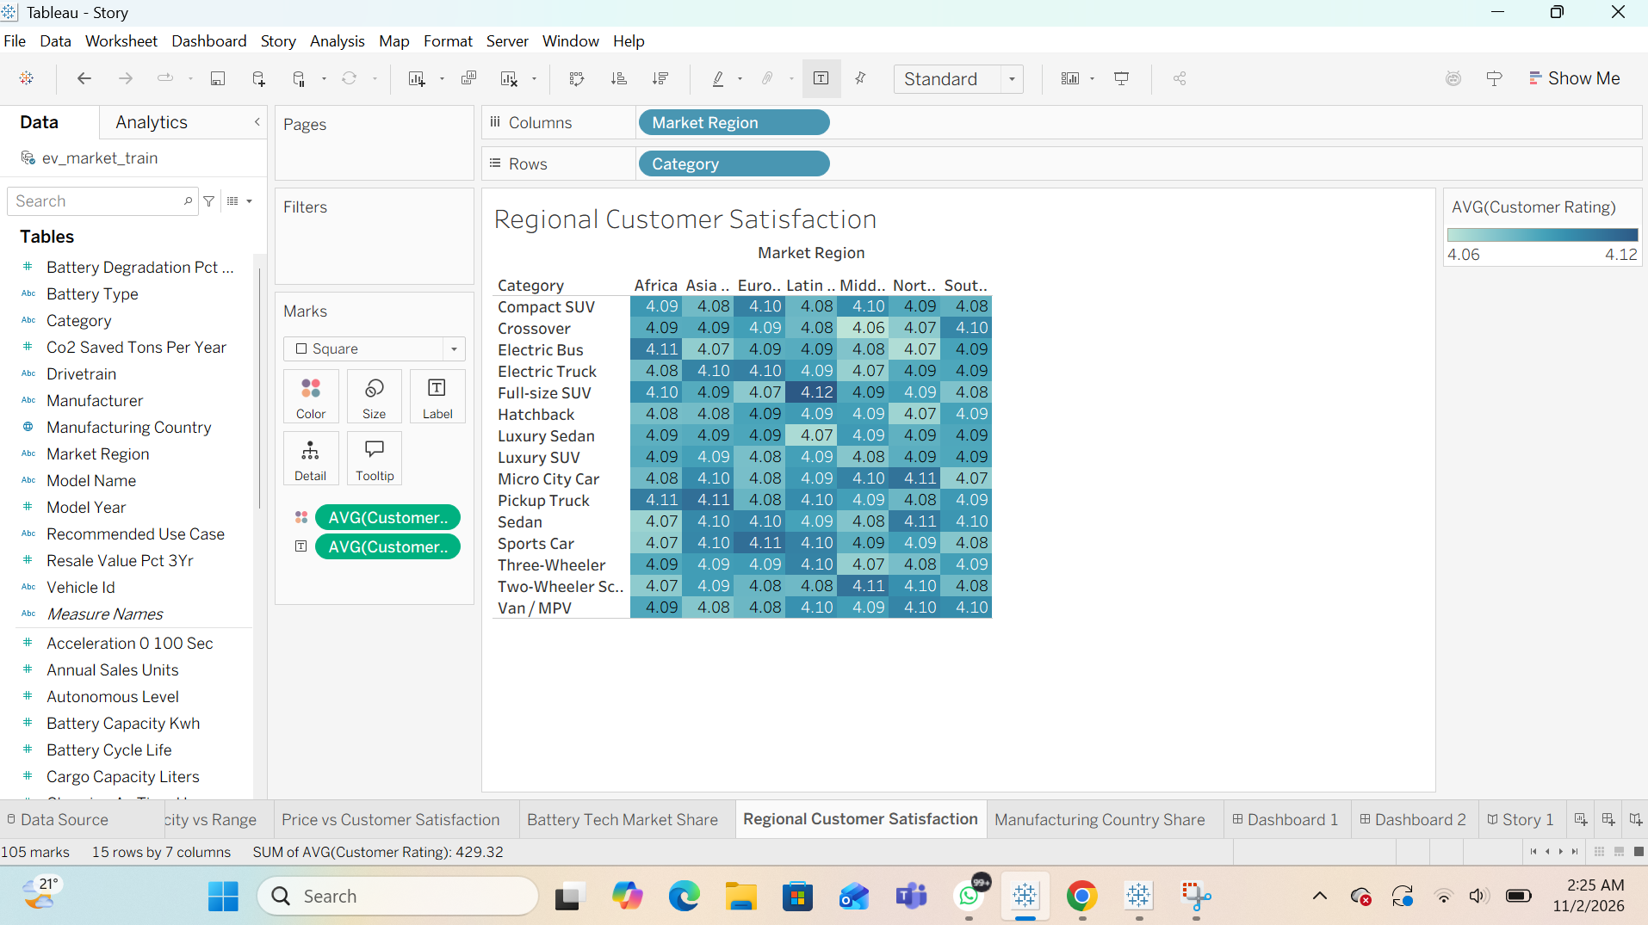

Business Question 9: How is sales volume distributed by manufacturing country?
Manufacturing Country Share — bubble chart; India 159,239,271, China 158,514,269 and Vietnam 157,312,671 annual sales units.
Tableau worksheet screenshot:
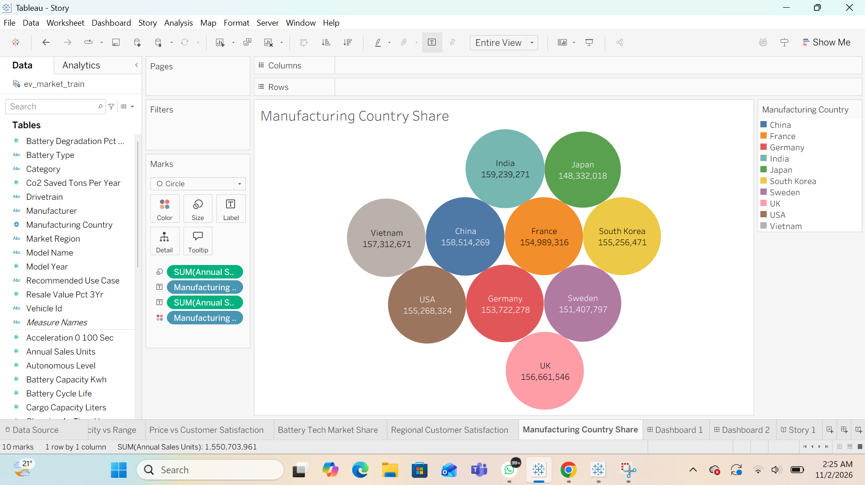

Business questions and evidence
All nine views were created in Tableau Desktop. Dashboard 1: https://public.tableau.com/app/profile/gitanjali.panjwani/viz/Dashboard1_17935482618430/Dashboard1?publish=yes
Dashboard 2: https://public.tableau.com/app/profile/gitanjali.panjwani/viz/Dashboard2_17935484601140/Dashboard2?publish=yes

